Job description

Section 1: Description

Job Title: Policy and Public Affairs Manager
Location: Communications and Marketing Directorate
Reports to: Senior Communications Manager
Salary: Grade 5
Date: September 2026

Section 2: Job purpose

We are seeking a dynamic Policy and Public Affairs Manager to shape the direction of our advocacy, research and influencing work across the UK.

You will develop an excellent understanding of the College and play a key role in ensuring we are effective in influencing public policy. You will play a key part in speaking up for our 15,000 Fellows and Members: physicians, surgeons, dentists and specialists in podiatric medicine and travel medicine.

In this role, you will build strong relationships with government, parliamentarians and partners across the healthcare sector. You will champion our Fellows and Members and ensure our policy and public affairs work is evidence-based and person-centred.

This is a strategic and externally-facing role, ideal for candidates with strong political insight and a passion for influencing policy. You will be expected to bring ideas, advise colleagues and office bearers, shape and deliver plans, and build relationships internally and externally.

Section 3: Organisation chart

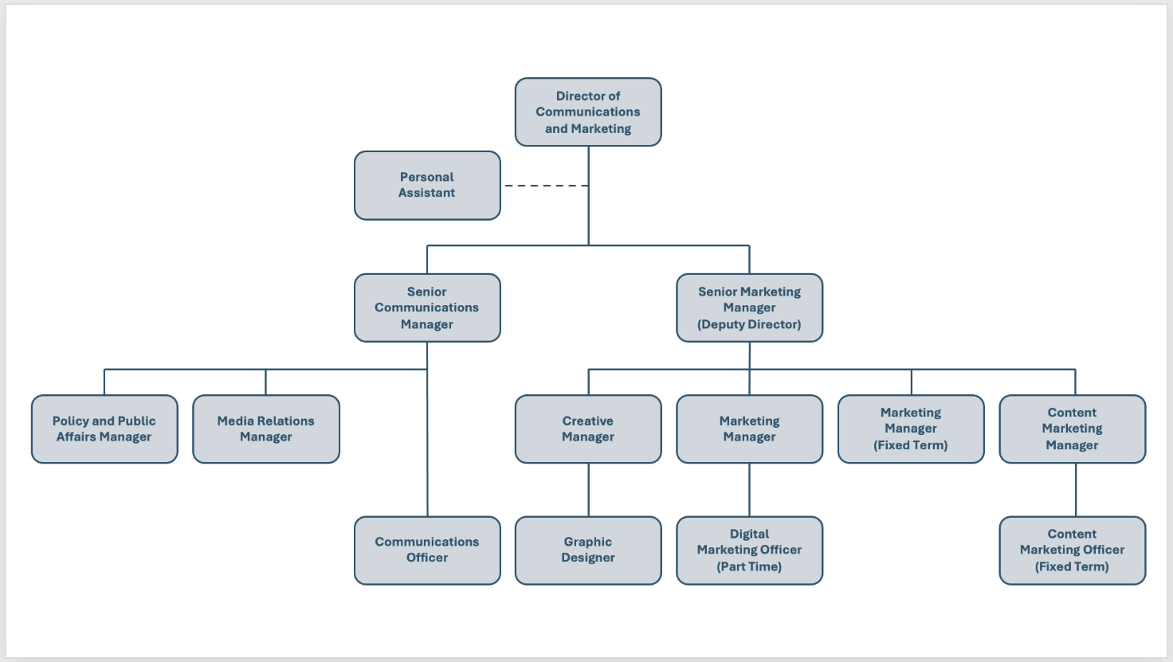

Section 4: Main responsibilities and role

- Proactively support the development of the College’s policy agenda, aligned with our strategic plan. This will involve developing expert knowledge and insight into the College and building strong relationships with colleague and office bearers.
- Support our Executive Board and College Leadership Team, providing timely political analysis and briefings to support leaders in making informed decisions and communicating policy positions externally.
- Development and delivery of the College’s policy and public affairs strategy, working closely with the Director of Communications and Marketing and Senior Communications Manager to ensure strong cross-College collaboration and forward planning.
- Horizon scanning the political environment for emerging trends, risks and opportunities.
- Work with our Honorary Secretary – our clinical lead for external affairs – and our UK Policy Network to draft consultation responses and position statements on a wide variety of healthcare matters relevant to our Fellows and Members. Provide reports on these to the Executive Board and College Leadership Team.
- Work closely with the Honorary Secretary, Director of Communications and Marketing and Senior Communications Manager to develop and deliver a research and engagement strategy that will enable the roll-out of College campaigns.
- Provide professional secretariat support for our UK Policy Network and Women’s Network, working closely with clinical leads.
- Ensure the College responds effectively to external enquiries and correspondence, maintaining high standards of communication.
- Day-to-day management of the College’s public affairs agency.
- Take part in a team rota to deliver regular news round-ups to our Fellows and Members.
- Any other duties that may be reasonably required.

Section 5: Planning and organising

The workload of the Policy and Public Affairs Manager will be dynamic and time sensitive and as such you will be required to plan independently to ensure all activities are delivered within set timelines.

This role demands excellent planning and organisational skills to ensure a schedule of activity is developed and maintained, and that campaigns and activities are coordinated and run according to set time frames.

Section 6: Decision making

The Policy and Public Affairs Manager will work independently, liaising with the Senior Communications Manager and Director of Communications and Marketing before publishing or issuing content and communications.

They will exercise sound judgment and take action within College policy and procedural guidelines, seeking advice from their line manager and/or Director of Communications and Marketing as required.

Section 7: Knowledge, experience and skill set required

The post holder will require the following:

Essential

- A degree-level education (or comparable experience) in a relevant subject.
- A minimum of three years of proven experience in a policy or public affairs role(s).
- A strong understanding of health and healthcare.
- Demonstrable understanding of policy making structures and processes in Scotland and the UK.
- Excellent oral and written communications skills, including a track record in the facilitation of discussions and delivering presentations.
- Ability to gather, analyse and use data to develop briefings, reports, communication and campaigns for different audiences.
- Strong organisational skills, including ability to manage multiple projects on tight deadlines.
- Ability to initiate and complete tasks with minimum supervision, seeking input from others as required.
- Ability to recognise sensitive subject matter and use language that is appropriate and fosters a supportive environment for the College’s audience.
- Reliable and willing to support a range of projects and tasks as required.
- Discretion, sensitivity and professionalism.

Desirable
- Experience supporting a membership or partnership organisation.
- Experience managing and generating engaging digital media content.
- Event management skills.
- Membership of a professional body.

