Job description

Section 1: Description

Job Title: Media Relations Manager
Location: Communications and Marketing Directorate
Reports to: Senior Communications Manager
Salary: Grade 5
Date: August 2026

Section 2: Job purpose

We are seeking a Media Relations Manager to play a key role in enhancing the College’s reputation as a thought leader within the healthcare sector. Working closely with the Senior Communications Manager, you will play a pivotal role in shaping and delivering our external communications strategy, building relationships with key journalists and creating compelling content that resonates with our Members and the wider healthcare community.

You will develop an excellent understanding, insight and knowledge of the College, telling our story, gathering content from our community of 15,000 Fellows and Members, strengthening our external voice, and raising our profile in the UK and internationally.

You will work closely with the Senior Communications Manager, Director of Communications and Marketing, and colleagues across our membership, education, assessment, heritage and fundraising functions to turn communications priorities into action.

This is a delivery role with real influence. You will be expected to bring ideas, advise colleagues and office bearers, shape plans and build relationships internally and externally.

Section 3: Organisation chart

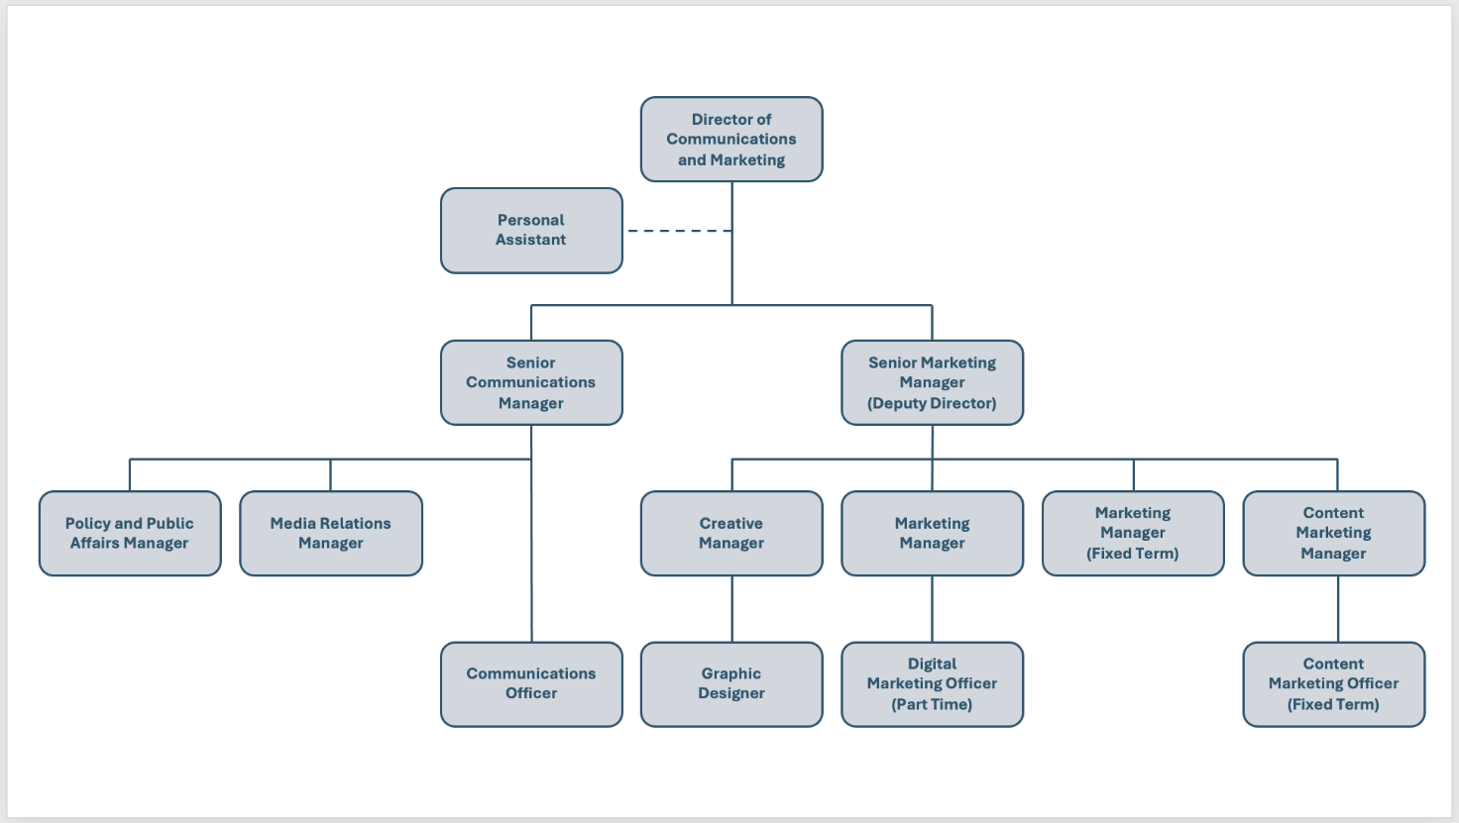

Section 4: Main responsibilities and role

- Build and maintain strong relationships with journalists, editors and key media outlets across print, broadcast and digital platforms. The post-holder will be the first point of contact for journalists at the College.
- Proactively pitch news stories, features and expert commentary to secure positive media coverage and position the College as a thought leader in healthcare.
- Write, edit and distribute high-quality content, including news releases, white papers, op-eds, blog posts and social media updates, as well as articles for our membership magazine, College Voice.
- Liaise with relevant office bearers and the College Leadership Team to respond to media enquiries in a timely and professional manner.
- Support the organisation of events, such a press conferences and roundtables, to amplify the College’s messages.
- Collaborate with office bearers and colleagues across the College to ensure content is accurate and consistent. Ensure communications are aligned with the College’s strategic plan and house style.
- Contribute to the production of multimedia content, such as videos, infographics and email newsletters.
- Prepare College spokespeople for media interviews and public appearances, including preparing key messages and briefing materials.
- Develop speaker and briefing notes for external events where the College is in attendance.
- Monitor media coverage and sentiment, providing timely reports on campaign performance to the President, Honorary Secretary and College Leadership Team.
- Take part in a team rota providing daily news updates from the healthcare sector to our Fellows and Members.
- Manage the College’s chosen agency for delivering media training to office bearers and senior staff, as well as our media monitoring agency.
- Leverage communications research and best practice to improve the effectiveness of communications campaigns and initiatives.
- Occasional out-of-hours work may be required for gathering content at major events.
- Any other duties that may be reasonably required.

Section 5: Planning and organising

The workload of the Media Relations Manager will be dynamic and time sensitive and as such you will be required to plan independently to ensure all activities are delivered within set timelines.

This role demands excellent planning and organisational skills to ensure a schedule of activity is developed and maintained, and that communications campaigns are coordinated and run according to set time frames.

Section 6: Decision making

The Media Relations Manager will work independently to gather stories and content, liaising with the Senior Communications Manager and Director of Communications and Marketing before publishing or issuing content.

They will exercise sound judgment and take action within College policy and procedural guidelines, seeking advice from their line manager and/or Director of Communications and Marketing as required.

Section 7: Knowledge, experience and skill set required

The post-holder will require the following:

- A degree-level education (or comparable experience) in communications or a related subject.
- A minimum of three years of proven experience in media relations, journalism or communications.
- Exceptional writing, editing and storytelling skills, with the ability to translate complex healthcare information into clear, accessible and compelling content.
- Strong, existing relationships with journalists and media outlets.
- Curiosity, an interest in healthcare and the ability to build rapport with Fellows and Members quickly.
- Excellent interpersonal skills with the ability to collaborate effectively with stakeholders internally and externally.
- Strong organisational skills and the ability to work independently in a fast-paced environment.
- Knowledge of media monitoring tools and analytics platforms.
- Experience of delivering and posting content for social media channels and websites.
- Experience of working with senior leaders as a trusted advisor.

Desirable
- Experience of working in a membership, academic or healthcare environment.
- Membership of a professional body.
- Experience of using software such as DotDigital and Monday.

