SCHOLARSHIP REPORT

This report should be completed by recipients of awards and scholarships from the Royal College of Physicians and Surgeons of Glasgow on completion of the activity for which they received their award or scholarship. Please complete all sections of the report form.
Please return your completed report via email to: scholarships@rcpsg.ac.uk
Or via mail to: Scholarships Committee Administrator, Royal College of Physicians and Surgeons of Glasgow,
232-242 St Vincent Street, Glasgow G2 5RJ, UK

Please use typeface when completing this form.
SECTION 1 | PERSONAL AND AWARD DETAILS
Title | Mr | PID | 110909
Surname | Hopper | Forename(s) | Graeme Philip
Scholarship/award awarded | College Travelling Fellowship | Amount awarded | £2000

SECTION 2 | PROJECT/VISIT DETAILS
Name of Institutions | - Mayo Clinic  - Midwest Orthopaedics at Rush
Location | - Minnesota, USA  - Chicago, USA
Aims and objectives | - To gain exposure to joint preservation techniques that are not seen in the West of Scotland including meniscal transplantation and cartilage transplantation  - To gain exposure to innovative techniques for treating multiligament knee injuries
Summary  Include methodology, results and conclusions if applicable | I am very grateful to the RCPSG for awarding me this travelling fellowship. I chose to visit the Mayo Clinic in Minnesota and Midwest Orthopaedics at Rush in Chicago which are both world renowned centre of excellence for orthopaedic surgery.  My supervisor at the Mayo Clinic was Dr Bruce Levy who is a specialist in sports medicine of the knee and hip. His clinical and research interests are complex knee trauma with a focus on knee dislocations and multiligament knee reconstruction. I was also able to spend time with Dr Aaron Krych and Dr Daniel Sarris who are also sports medicine experts but with a particular interest in cartilage restoration and transplantation. I was fortunate to be involved with some very interesting cases including a multiligament knee injury in a patient who was 300lbs, a revision ACL reconstruction with meniscal transplantation and osteochondral allograft transplantation and an interesting MACI procedure.  My supervisor at Midwest Orthopaedics was Dr Brian Cole who is also a sports medicine expert with a particular expertise in meniscal transplantation, cartilage transplantation as well as regenerative medicine including orthobiologics, platelet rich plasma (PRP) and bone marrow aspirate concentrate (BMAC). He is also the team physician for the Chicago Bulls, Chicago White Sox and Chicago Fire. I was able to gain exposure to all of these areas both in the clinic and in the operating room as well as reviewing some retrospective cases. However, my main learning point from my time with Dr Cole was the way he used all available non-operative measures before embarking on surgery unless it was absolutely necessary which is something I will definitely take onboard in my future career.
Learning outcomes  Detail here how the aims and objectives were met | - To gain exposure to joint preservation techniques that are not seen in the West of Scotland including meniscal transplantation and cartilage transplantation  Throughout my fellowship I gained significant experience in meniscal transplantation and cartilage transplantation both in the clinic setting and in the operating room. Furthermore, I was able to grasp the concept of these joint preservation techniques in relation to ligamentous surgery around the knee. Most importantly, I was fortunate to be able to see innovative techniques in these world renowned centres of excellence.  - To gain exposure to innovative techniques for treating multiligament knee injuries  During my fellowship I gained fantastic exposure to multiligament knee injuries. It was particularly interesting to experience the whole patient journey from the initial appointment in the clinic to surgery and then rehabilitation and often return to sport. Additionally, I was able to attend the lab for cadaveric demonstrations of various innovative techniques that are soon to be published.
Evaluation  How has this scholarship/award impacted on your clinical/NHS practice or equivalent? | I am very grateful to the RCPSG for awarding me this travelling fellowship as I believe it will be instrumental in my career as a knee surgeon. It has allowed me to expand my knowledge and surgical repertoire for cases where joint preservation is applicable. In particular, I believe it will be invaluable to the treatment of my future patients.

SECTION 3 | IMAGES

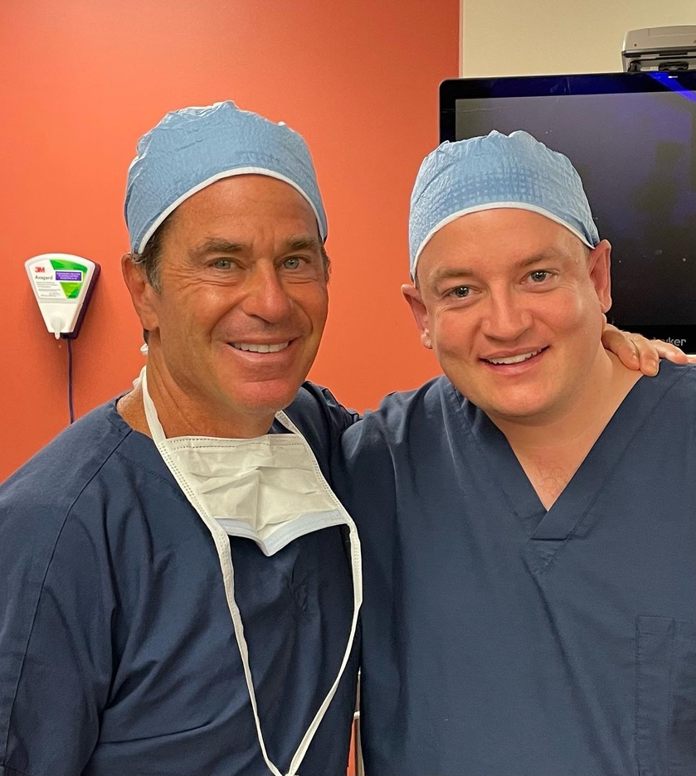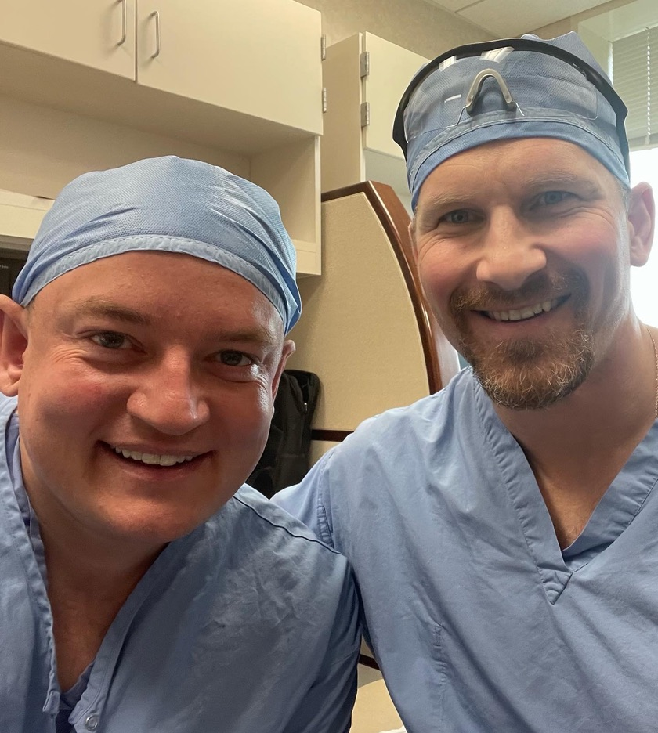

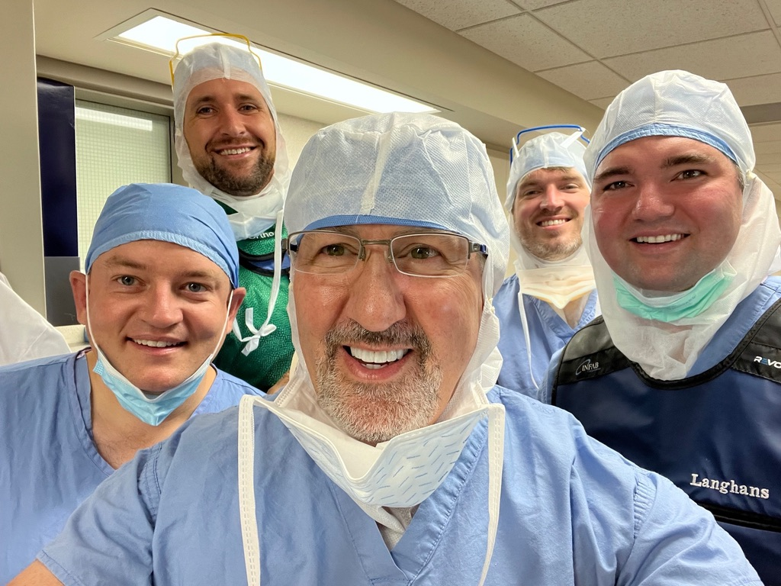

SECTION 4 | EXPENDITURE
Breakdown of expenditures  Please demonstrate how the scholarship/award funding was used to support your project/visit | This award has been used to help fund travel, accommodation and sustenance during my visits to the USA.

SECTION 5| PUBLICATION
Scholarship/award reports may be published in College News. Please tick here if you agree to your report being published. | I give permission for my report to be published in College News  If your report is selected for publishing, the editor of College News will be in touch to discuss this with you.

All Information concerning you as an individual will be held and processed by the College strictly in accordance with the provisions of the General Data Protection Regulation (GDPR) (Regulation (EU) 2016/679). Such data will be used by the College to administer its relationship with you as a Fellow or Member. We will not, without your consent, supply your name and address to any third party except where (1) such transfer is a necessary part of the activities that we undertake, including the provision of library services (if applicable) or (2) we are required to do so by operation of law. As an individual you have a right under the General Data Protection Regulation (GDPR) (Regulation (EU) 2016/679) to obtain information from us, including a description of the data that we hold on you. Should you have any enquiries about this right please contact Membership Services Administrator at the College.

